Startup Documentation

**The following will walk you through how to get started with development on this application**

**Environment**

Please have the following downloaded and installed before continuing:

* Java 8, Maven, STS (Or Eclipse but will require additional instructions), Angular CLI, npm, Git, SQL Developer, and RDS

**Generate a Local Database**

<https://raw.githubusercontent.com/revaturelabs/cms-content-service/dev/scripts/CMSForceSQL.sql>

**Setup Environment Variables**

**Environment Variables**

* **DB_URL** - Url connection to the database
* **DB_USER** - Username for the database
* **DB_PASS** - Password for the database
* **EUREKA_URL** - Url to the discovery service

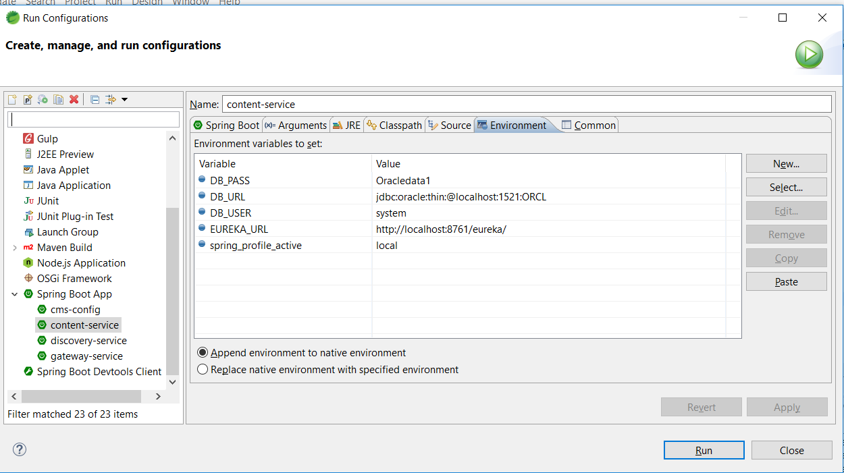

**Clone the project repositories to your local machine:**

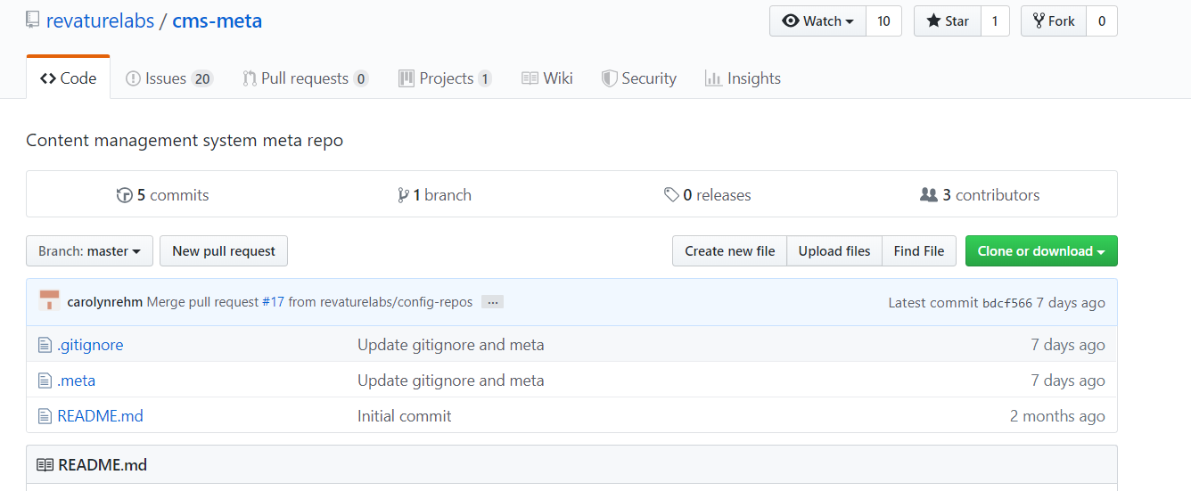

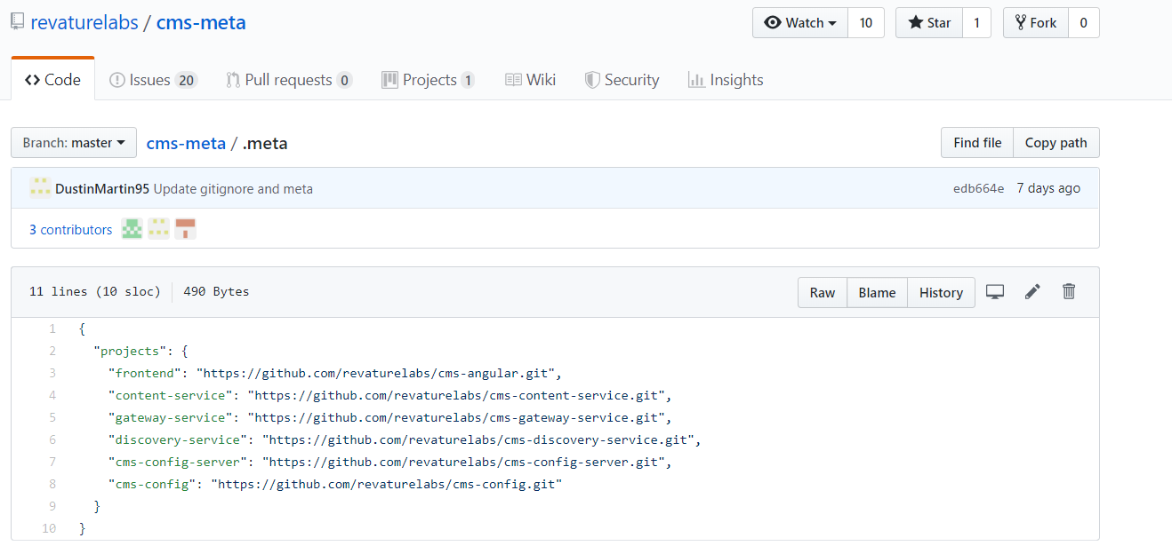

1. Create CMS folder.
2. C:\Ashujauhari2019\Revature\CMS Project3\cms>git init
3. C:\Ashujauhari2019\Revature\CMS Project3\cms>meta init
4. C:\Ashujauhari2019\Revature\CMS Project3\cms>meta git clone <https://github.com/revaturelabs/cms-meta.git>
5. 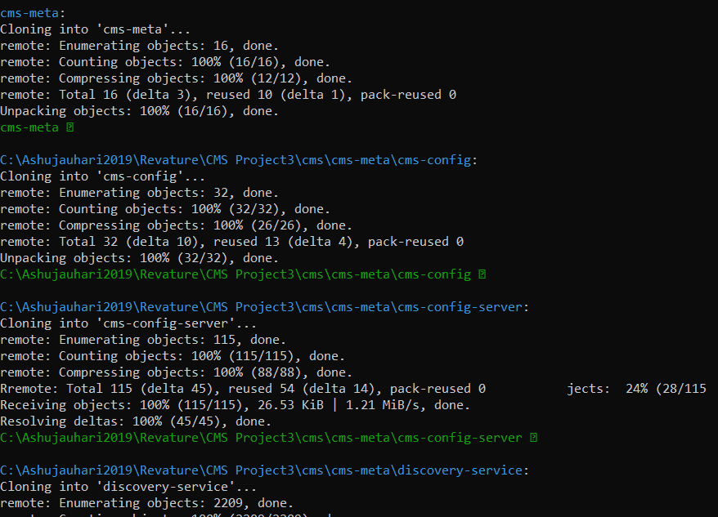
6. 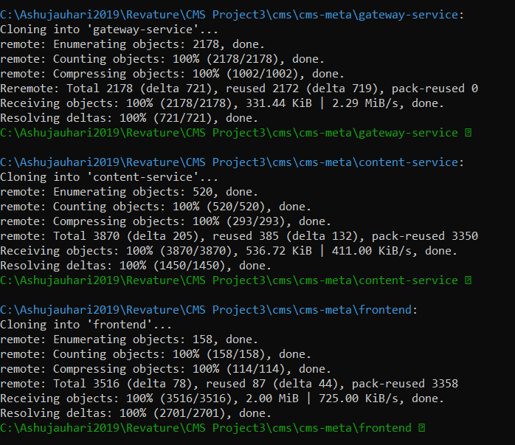
7. 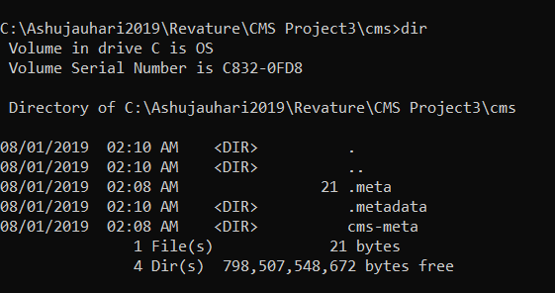

C:\Ashujauhari2019\Revature\CMS Project3\cms>cd cms-meta

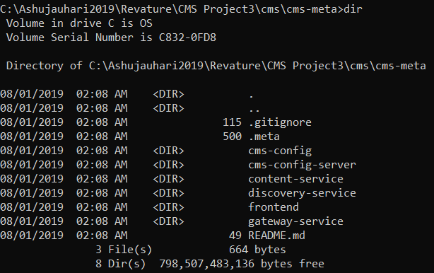

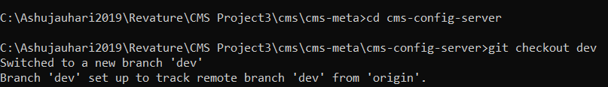

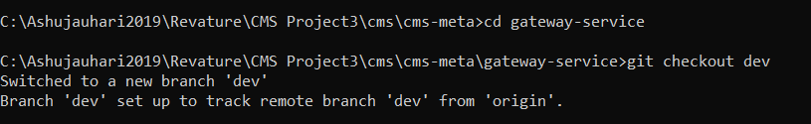

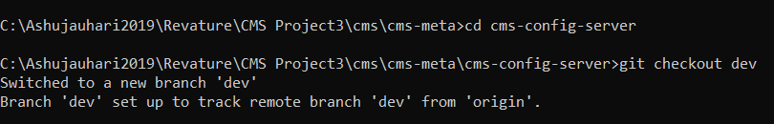

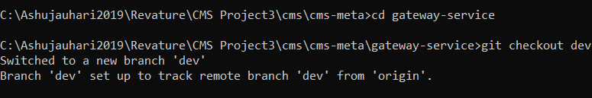

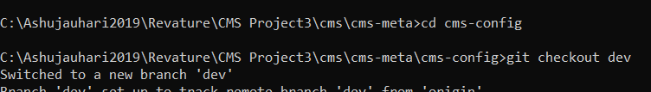

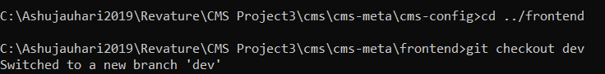



Verify

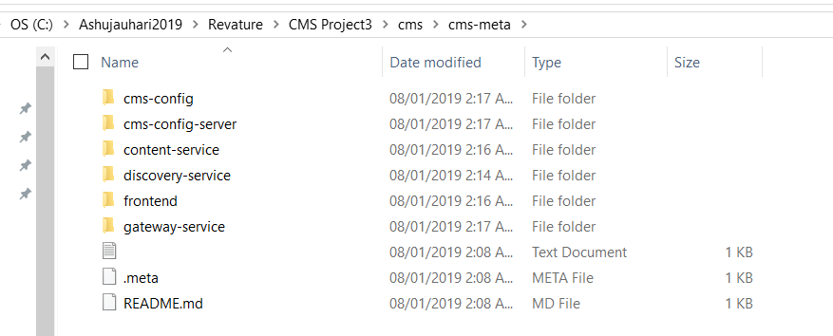

**Import the projects in new workspace of STS:**

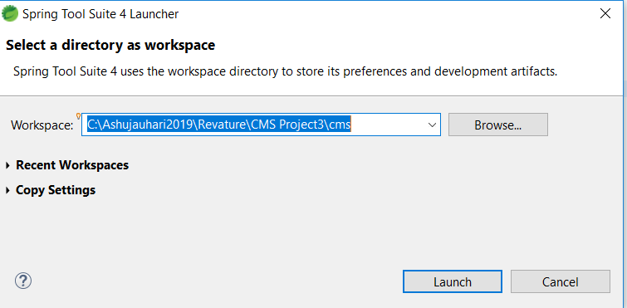

Import all Maven->existing project->

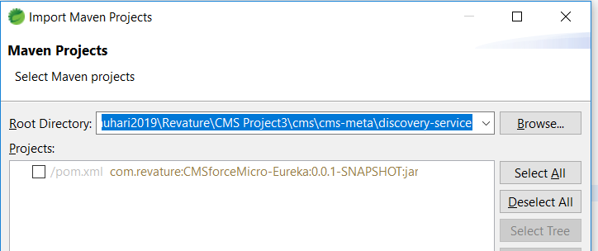

Repeat process the for all projects

1. Install meta (this allows you to run git commands across multiple repos):

npm i -g meta

1. Create a new directory for your meta project mkdir: [folder name]
2. Initialize a new git repository in your new dir:

cd [folder name] && git init

1. Initialize your new repository as a meta repo:

meta init

1. Clone the meta repository

meta git clone https://github.com/revaturelabs/cms-meta.git

cd cms-meta

1. Create branches based off dev for each repository.

Git checkout dev

**Set up work-space for STS**

1. In STS, got to file -> open projects from file system
2. Import all projects from cms-meta

**Eureka Default Zone**

* Discovery service

**Config Server**

* Centralized configuration

**Zuul Default Zone**

* You'll want to set your Zuul's defautZone to wherever you are hosting your Eureka(discovery) server.

**Application Server (CMSForce)**

* Content service

**Run the services:**

* If you set up windows, or OS environment variables, you will have to restart STS for it to have access to the OS environment variables if STS was running during setup.
* In STS, all of the services must be ran as a Spring Boot App

1. Run -> Run Configurations -> Profile: local -> Apply for all 4 services
2. Run Eureka Discovery Service
3. Run Config Server
4. Run Zuul Gateway Service
5. Run Content Service

**Run the Angular front end**

1. In a command line, navigate to the frontend directory of cms-meta
2. Install the dependencies:

npm install

1. Run the Angular development server

ng serve

* In your browser, navigate to <http://localhost:4200/>

Test

1 . Rc->Discoveryservice-> Run->Runconfiguration->select local in profile under discovery-service-+enter

1. Check eureka in browser

Setup for cms>

C:\Users\Ashu Jauhari\.m2\repository

------------Setup driver - ---

* 1. STS shows all folder
  2. Run Discovery service -> run- run-configuration -> environment –> set local profile
  3. Run config server-> set local profile -> run configuration-> set local
  4. Content – service
     1. Make sure oracle 12.1.9
     2. Run below in content-service

mvn install:install-file -Dfile=src/main/resources/ojdbc7.jar -DgroupId=com.oracle \  
    -DartifactId=ojdbc7 -Dversion=12.1.0 -Dpackaging=jar

* 1. Rc->run->runconfiguration->environment -> local-> FAIL TO DETERMINE SUITABLE DRIVER CLASS
  2. Open configdetail on browser
  3. Setup environment variable -> STS-> run configuration -> environment variable-> DB_URL->DB_Password-> DB_USER
  4. As there were changes in cms-config-server and gateway service
  5. Go bootstrap.yml-> in dev -> eureka.client.service-url:defaultzone: <http://localhost:8761/eureka/>

// -DB Script

/*Setup Script*/

drop table content_module;

drop table module;

drop table content;

create table content(

c_id number (10) primary key,

title varchar2 (200) not null,

format varchar2 (200) not null,

description varchar2 (200) not null,

url varchar2 (200) not null,

created number (20),

last_modified number (20)

);

create table module(

m_id number (10) primary key,

subject varchar2 (200) unique,

created number (20)

);

create table link(

cm_id number (10) primary key,

fk_c number (10) ,

affiliation varchar2 (200),

fk_m number (10),

foreign key (fk_c) references content(c_id) on delete cascade,

foreign key (fk_m) references module(m_id)on delete cascade

);

create sequence HIBERNATE_SEQUENCE;

select * from module;